**Mary Jo Wolfe Moore McCall and Family**

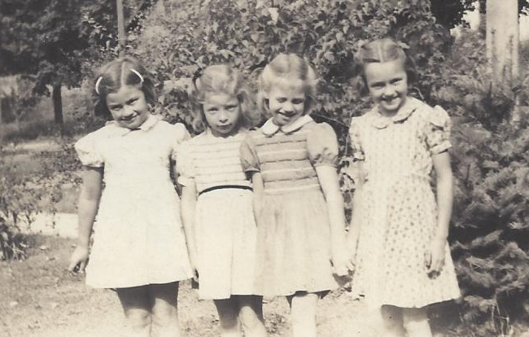

Dotty Jo List, Marilyn Jean Evans, Mary Jo Wolfe, Nancy Paxton

Mary Jo's sixth birthday - 20 Sept 1943

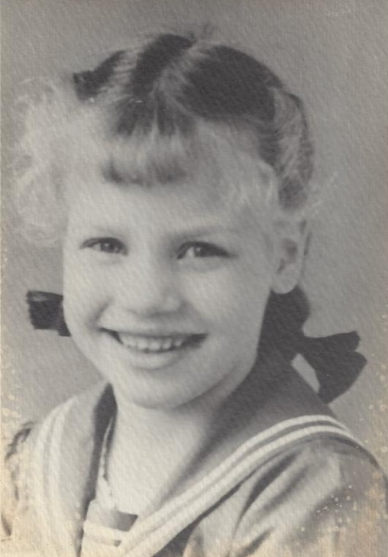

Mary Josephine Wolfe – 1943